Surveying and Planning through Electronic Applications and Referrals

SPEAR News
July 2023

Welcome to the July issue of the SPEAR newsletter.
This newsletter provides details regarding SPEAR Release 5.7, an update on ePlan, as well as SPEAR handy hints.

SPEAR update

New or amended functionality will become available to SPEAR users from 31 July 2023, following SPEAR Release 5.7. This includes changes to support the phasing out of Owners Corporation Additional Information (OCAI), OC1 and OC2 forms supplied by the lodging party, plus the introduction of Transport Survey Plan (formerly known as VicRoads Survey Plan) applications.

Owners Corporation Additional Information
OCAI will be supplied by applicant contacts (Licensed Surveyors) instead of lodging parties for plans released for lodgement after SPEAR Release 5.7. Applicant contacts already enter this information into SPEAR when attaching the Owners Corporation spreadsheet.
To assist with this requirement, changes have been made to SPEAR to:
- allow applicant contacts to amend or update OCAI before the plan is lodged with Land Use Victoria; and
- enable Land Use Victoria to requisition changes to OCAI after lodgement, removing the need for lodging parties to withdraw a lodgement to amend OCAI.
Lodging parties will continue to supply OCAI for some applications, and SPEAR will prompt SPEAR ELN Subscribers when this is required. This includes:
- plans already released for lodgement by the applicant contact when SPEAR Release 5.7 is implemented; and
- plans where an Owners Corporation spreadsheet was not uploaded in SPEAR.
Note: There are no changes to Owners Corporation Notification of Making Rules (27E(1) SA, formerly OC5) applications. Lodging parties must continue to submit these forms when necessary.
After the release, Owners Corporation dealing numbers (e.g. OC654321A) will no longer be generated. Customers wishing to obtain a copy of this information can do so through a search of the plan Instrument (e.g. PS900500A).

Transport Survey Plans

After Release 5.7, SPEAR will support Transport Survey Plan (TSP) applications. Formerly known as VicRoads Survey Plans, TSP applications are submitted to the Department of Transport and Planning (DTP) for approval.

Applicant contacts will create the TSP application and provide the relevant survey plan numbers (e.g. SP012345) and documents in SPEAR. Once submitted, the applications will be assessed by DTP. If there are any amendments required to the plan or survey documents, these will be requested in SPEAR prior to DTP approving the application.

For a complete list of enhancements, refer to the SPEAR Release Notes.

ePlan update
Following the completion of the ePlan Pilot in December 2022, the Electronic Subdivisions Unit (ESU) has been supporting a host of new surveying firms that have recently started their ePlan journey. So far this year, 45 surveying firms have embraced ePlan, with the creation of more than 1300 ePlan versions in the ePlan Portal. These plan versions support over 300 Subdivision Act 1988 applications, 189 of which have been fitted to SPEAR. It is fantastic to see this activity by surveying firms as they progress towards adoption of ePlan.
The support enquiries received from surveying firms have provided valuable learning opportunities for both ePlan users and ESU as we continue to enhance system functionality and improve our training and support materials.
The ePlan section of the SPEAR website has also been updated with new content and improved navigation of training resources. We encourage all Applicant Contacts to explore the new and improved pages.

About ePlan: General Information
ePlan Overview
ePlan Fact Sheet
Frequently Asked Questions
ePlan Release Notes

Getting Started: Training Resources
SCFF Layers, Examples and Templates
SCFF Plan Preparation and Instructions
SCFF Guidance Notes
Validation Rules
ePlan User Guides
ePlan Training Videos
On 15 June 2023, ESU hosted an online ePlan training session aimed at providing Applicant Contacts with an introduction to ePlan and showcasing the end-to-end ePlan preparation for a straightforward plan. The session was well attended, with more than 160 participants from 77 surveying firms joining online. ESU will be hosting additional ePlan training, dates. These will be shared though a SPEAR broadcast message, so stay tuned!

Handy hints

Saved Searches Functionality
The Saved Searches functionality allows users to save frequently used search criteria in the Application List. Saved searches can assist the use of the Application List as a reporting tool or frequently referred to specific search criteria.

The following parameters can be stored within a saved search:
- applied filters
- entered search terms
- column sort order
- applications displayed (i.e. current/completed/all etc.)
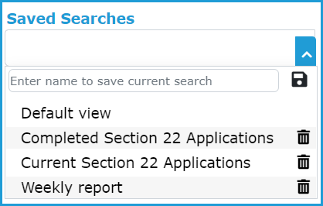
Users will assign a name to each search for easy recall. Pre-saved searches will appear in the list and can be clicked on to run as required.

A saved search can be deleted by clicking on the delete icon.

Photo Functionality
In November 2022, the ‘Add Photos’ functionality was enhanced to support common image formats, including JPG and PNG images, in addition to the previous functionality which supported PDF format.
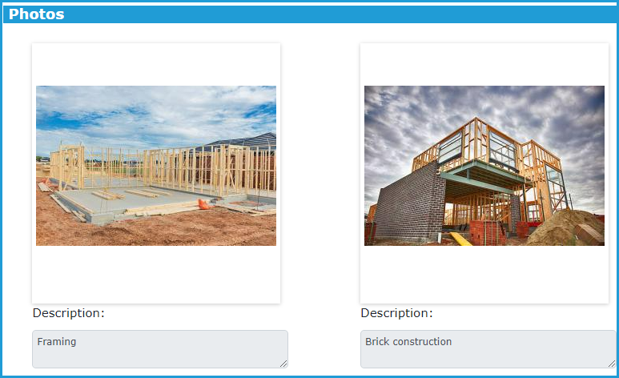
Applicant Contacts can now upload multiple photos (10 at a time and a maximum of 50 images per application) and can provide a description for each photo.

Reminder
The SPEAR Service Desk is not responsible for the examination and registration of plans, and as such does not provide plan status updates or information regarding lodged applications.
If you would like to be notified when a plan is picked up for examination, you can subscribe to a Property Transaction Alert using LANDATA®. For more information, see current registration processing times on the SPEAR website.
Photos can be viewed in SPEAR and are displayed as a gallery with their description shown underneath. If required, photos can be downloaded into a ZIP folder, maintaining their original size or as a PDF with images shown as thumbnails.
If users still wish to attach photos in a PDF, this can still be achieved using the ‘Other Actions’ drop-down list and selecting ‘Add Other Document Type’ to attach the PDF.

Keep your organisation’s contact details up to date
It is important that your organisation’s address, phone number and email address is kept up to date in SPEAR. These details can be updated by Local Adminstrators at your organisation.
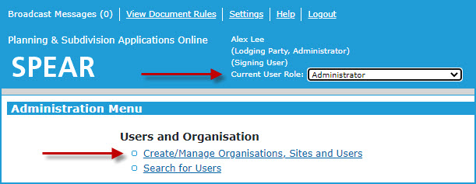
Local Administrators can access the adminstration menu by selecting ‘Administrator’ from their Current User Role drop-down located in the blue banner of the applciation list screen. From the administration menu, click ‘Create/Manage Organisations, Sites and Users’ and then select ‘Edit’ to modify the organisation details.
For further information about the Local Administrator functions, please refer to SPEAR User Guide 23 which can be found here.
Note: Updating details in your own user setting will only update your individual details and not the details of your organisation.
Feel free to contact the SPEAR Service Desk if you need assistance with this task, or if you do not believe you have a Local Admistrator at your organisation.

SPEAR training
The following dates have been scheduled for our quarterly online training sessions. If you wish to attend, please save the date, and use the self-registration link which will be shared via a SPEAR broadcast message closer to the respective dates. If you have any queries regarding training, please contact the SPEAR Service Desk on (03) 9194 0612.
Lodging Parties
Wednesday 9 August and Wednesday 8 November
Responsible Authority – councils
Thursday 10 August and Thursday 9 November
Applicant Contact
Wednesday 16 August and Thursday 16 November
Statutory & non-statutory referral authorities
Wednesday 16 August and Thursday 16 November

Support
The SPEAR team seeks to ensure your questions and issues are resolved quickly.
Contact the SPEAR Service Desk on (03) 9194 0612:
Press 1 for SPEAR assistance
Press 2 for ePlan enquiries
Press 3 for Plan Branch contact details
Alternatively, you can send your enquiry by email to spear.info@delwp.vic.gov.au

Contact SPEAR
T: (03) 9194 0612
E: spear.info@delwp.vic.gov.au
W: www.spear.land.vic.gov.au
to a Property Transaction Alert using LANDATA®. For more information, see current registration processing times on the SPEAR website.

Need more information?
Find out more about the government’s
initiatives at dtp.vic.gov.au

